PROGRAMMING 2B
[Company name] | [Company address]
st10377205
Kamohelo Ignatious Simata
INTRODUCTION
This is a monthly claim system designed to help lecturers submit claims. Overall, in this monthly claim system, we plan to cover everything from documenting, database schema design, and planning to designing the system. The solution is to allow all lecturers to submit their claims with supporting documents and to track those claims after submission. The aim of the system is also to reduce errors by forcing lecturers to provide accurate documentation and complete all required fields before submission. Through mandatory uploads, structured forms, and input validation, the system minimizes mistakes and ensures that claims are consistent and reliable. The program coordinator will then review and pre-approve the claims, after which the program manager finalizes them by approving or rejecting them. To achieve this, all users will need to register and log in according to their roles.

Purpose
The purpose of this system is to make digital claims, reduce delays, and improve data capturing. By doing this, lecturers can submit their claims faster, while coordinators and managers can keep proper records without confusion. Overall, the aim is to reduce errors, improve transparency, and make the claim process more efficient.
Users & Roles
- Lecturer Registers, submits claims with supporting documents, and tracks claim status.
- Program Coordinator Reviews claims, checks documents, and either approves or rejects them.
- Program Manager (PM) Handles claims that they have been pre-approved by the coordinator and gives the final decision (finalize or reject).
Objectives
- My core focus is to cater to the different user roles in the system (lecturers, coordinators, and program managers).
- Create a secure and user-friendly platform with a clear and efficient claiming system.
- Ensure a transparent approval workflow so lecturers always know where their claims stand.
- Maintain strong data integrity through a structured database (Users, Modules, Claims).
- Reduce errors by enforcing input validation and requiring supporting documents

System Workflow
1 Lecturer register logs in Submits claims - track claims
2. claims automatically marked pending with submission timestamp
3 .Program coordinator reviews
Approve claim status =Approved
Reject - claim status = Rejected
4 Program Manager reviews
Finalize- claim status = Finalized
Reject claim status = Rejected by PM
5 Lecture Track all claims by timestamp and history
Requirements Gathering
For the system to be useful, the following pages and fields were identified.
Functional Pages
- Registration Page – will allow new users to create an account with their role whether they are a lecturer, Program coordinator, or Program Manager.
- Login Page – Users will be able to login to the system depending on their role.
- Claim Submission Page – lecturers will be able to fill in the claiming details and upload supporting documents.
- Claim Tracking Page –The lecturers can view the status of all their claims, including timestamps and feedback.
- Coordinator Approval Page –Program coordinators can review pending claims, check attached documents, and either pre-approve or reject them.
- Program Manager Finalization Page – Program Managers will handle claims that have already been reviewed by Program coordinators and give the final decision.
Functional Fields
- User Information: name, email, role, password, date of registration.
- Claim Information: module, number of sessions, total hours, hourly rate, total amount (auto-calculated), status, timestamps.
- Supporting Documents: upload fields restricted to certain formats (PDF, JPG, PNG) with a maximum file size.
- Feedback Fields: for coordinators or PMs to give reasons if a claim is rejected.

Architectural and Design
The architecture I am using for this system is the MVC (Model-View-Controller) design, because it keeps everything organized and makes it easier to manage. My focus here is to separate the system into three layers so that each part has its own responsibility.
- Models: I am building models to represent data entities, like Users, Claims, and Modules. For example, the Users model will store information such as names and surname, emails, roles, date, time and passwords, while the Claims model will handle all claim-related details and connect them to modules.
- Views: I am creating views to serve as the user interface. This includes the forms for submitting claims, the tables for tracking them, and the dashboards for coordinators and program managers. The views are designed to be clean and easy to use, so each role can quickly do their part.
- Controllers: I am creating controllers to connect models and views. This is where the business logic happens like checking input validation, calculating totals, or updating the claim status when a coordinator or manager acts.

Frontend & Backend
- Frontend: I am working with HTML and CSS and adding some JavaScript to make forms responsive and user-friendly.
- Backend: I am using C# because it is strong at handling logic, workflows, and validation.
- Database: I am using SQL (MySQL) to capture information in a structured way. The database holds the Users, Modules, and Claims tables, and enforces relationships between them so that everything stays consistent.

Security & Validation
When I thought about security, my main goal was to make sure that each functional page and field stays reliable and safe.
- Registration & Login Pages: Passwords are stored as salted hashes in the Users table, so no plain text is ever saved. Each role (Lecturer, Coordinator, PM) is validated at login, meaning users only see the pages they’re supposed to.
- Claim Submission Page: Input validation checks things like valid email formats, numeric values for sessions and hours, and ensures rates are realistic. Supporting documents are restricted to PDF/JPG/PNG and checked for file size before uploading.
- Claim Tracking & Approval Pages: Every action (approve, reject, finalize) is recorded with timestamps and the user ID in the Claims table. This gives an audit trial for accountability.
- Authorization: Lecturers can only create and view their own claims. Coordinators can only approve pending claims, and PMs can only finalize already-approved claims.
- Data Integrity: Foreign keys between Users, Modules, and Claims enforce relationships, so there are no “orphan claims” without lecturers or modules.

Step 7: Detailed Design & Workflow Implementation
The workflow ties directly into the pages and tables you already defined. I designed it to flow role by role so that every user interacts with the system in a clear way.
- Models (Database Entities)
  - Users Model stores user info (User_id, name, surname ,email, role, date ,time and password hash ).
  - Modules Model stores module info (module_id, lecturer_id, name).
  - Claims Model stores claim details (Claims_id , Users_id ,module_id ,sessions ,hours , rate ,total amount, status , submitted date , submitted time, pre-approved date , pre-approved time ,finalized date , finalized time, document path

- Claim Submission (Lecturer)
Lecturer logs in goes to Claim Submission Page Fills in claim fieldsSystem auto-calculates total amount (hours × rate) Lecturer uploads supporting documents Claim stored in Claims table status
Pending + timestamp.
- Claim Approval (Coordinator)
Coordinator logs in goes to Coordinator Approval Page Reviews pending claims with all details and documents
status updated = Approved+ timestamp
status updated = Rejected (feedback stored) + timestamp.
- Claim Finalization (Program Manager)
PM logs in Reviews pre-approved claims
Finalize
status = Finalized +Timestamp.
Reject
status = Rejected by PM+ Timestamp.
- Claim Tracking (Lecturer Dashboard)
- Lecturer will log in and go to Claims Tracking Page, and will see all claims (Pending, Approved, Rejected, Finalized).
- Full history is shown with timestamps.
- Optional reporting by module, month, or lecturer available for PM/Coordinators.

Step 8: UI / UX Design Choices
1. Layout
- Sidebar for navigation (Dashboard, Submit Claim, Track Claim, Approvals, Reports).
- Main content area displays forms, claim tables, and dashboards.
- Clear separation between input forms (submission) and output data (tracking & reports).
2. Colors & Status Indicators
- Base theme: White background with gradient green accents (mint green → emerald, green) for a modern and professional appearance.
- Status badges for claims:
  - Pending = Yellow
  - Approved = Green
  - Rejected = Red
  - Rejected by PM = Orange
  - Finalized = Blue
3. Responsive Design
- Sidebar collapses on mobile for better visibility.
- Forms stack vertically on smaller screens.
- Tables become horizontally scrollable if content is too wide.
- Ensures accessibility across desktop, tablet, and mobile devices.
4. User Experience Considerations
- Auto-calculation of total amount to reduce manual errors.
- Upload confirmation messages for supporting documents.
- Color-coded statuses for quick visual recognition.
- Role-based dashboards so users only see the actions relevant to their role.
- Search and filter options for claims (by status, module, or date).

Database design
UML

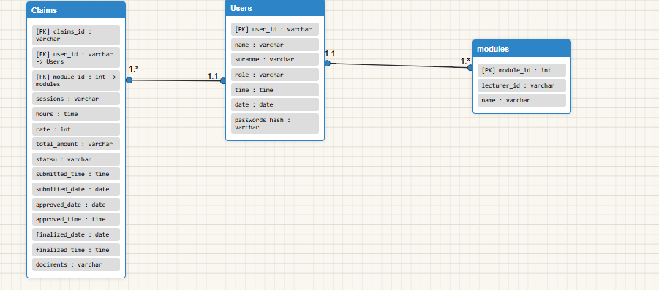

1. Users Table
This table stores all the people who interact with the system: lecturers, program coordinators, and program managers.
Attribute name | datatype | Character length | Primary or foreign key
User_id | int | Auto increment | PK
Name | varchar | 50 | none
Surname | varchar | 50 | none
Email | varchar | 100 | none
Role | varchar | 100 | none
Date | date | 20 | none
Time | time | 10 | none
Password_hash | varchar | 500 | none

2. Modules Table
This table holds information about the academic modules taught by lecturers

Attribute name | datatype | Character length | Primary or foreign key
Module_id | int | Auto increment | PK
Lecturer_id | int | Auto increment | FK
Name | varchar | 50 | none

3. Claims Table
This is the core of the system where lecturers’ claim data is stored.
Attribute name | datatype | Character length | Primary or foreign key
Claims_id | int | Auto increment | PK
Users_id | int | Auto increment | FK
Module_id | int | Auto increment | FK
Sessions | varchar | 50 | none
Hours | time | 20 | none
Rate | int | 500 | none
Total amount | varchar | 250 | none
Status | varchar | 20 | none
Submitted date | Date | 20 | none
Submitted time | time | 20 | none
Pre-approved date | date | 20 | none
Pre-approved time | time | 20 | none
Finalized date | date | 20 | none
Finalized time | time | 20 | none
Document path | varchar | 50 | None

Relationships
- Each lecturer can teach many modules; each module is taught by one lecturer.
- Each lecturer can submit many claims; each claim belongs to one lecturer.
- Each module can have many claims; each claim is linked to one module

Project Plan
Tasks & Dependencies
1. Requirement Gathering
- Duration: 7 days
- Dates: 02/09/2025 – 08/09/2025
- Collect information about lecturer claim processes.
- Identify problems with manual submissions.
- Dependency: None.
2. System Design
- Duration: 7 days
- Dates: 09/09/2025 – 15/09/2025
- Draw workflow diagrams and use cases.
- Design database schema (Users, Modules, Claims).
- Dependency: Requirement Gathering.
3. Frontend Development
- Duration: 14 days
- Dates: 16/09/2025 – 29/09/2025
- Build registration and login pages.
- Create claim submission form and tracking dashboard.
- Dependency: System Design.
4. Backend Development
- Duration: 14 days
- Dates: 23/09/2025 – 06/10/2025 (overlaps with end of Frontend work for efficiency)
- Implement logic in C# (validation, claim calculations, status updates).
- Add role-based permissions for Lecturer pages ready., Coordinator, and PM.
- Dependency: schema and frontend Database
5. Database Integration
- Duration: 7 days
- Dates: 30/09/2025 – 06/10/2025 (parallel with backend work)
- Implement Users, Modules, and Claims tables in SQL.
- Test relationships and foreign keys.
- Dependency: Backend and database design.
6. Testing & Debugging
- Duration: 7 days
- Dates: 07/10/2025 – 13/10/2025
- Test each functional page for correctness.
- Check input validation and role-based access.
- Dependency: System must be built and integrated.
7. Deployment & Feedback
- Duration: 7 days
- Dates: 14/10/2025 – 20/10/2025
- Deploy prototype in a test environment.
- Collect feedback from sample lecturers, coordinators, and managers.
- Make improvements based on feedback.
- Dependency: Testing completed

